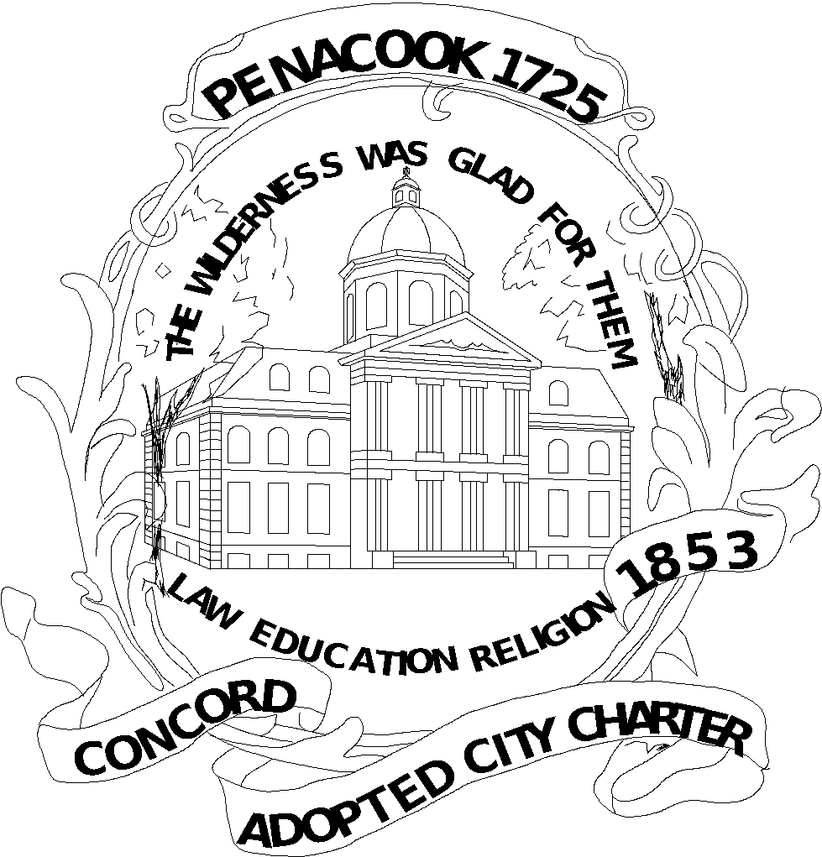
CITY OF CONCORD
MEETING MINUTES

CONCORD PUBLIC LIBRARY BOARD OF TRUSTEES

Monday, November 1, 2021
6:00 PM
Library Auditorium

- Attendance: Jeremy Clemans, Chris Casko; Lisa Sands; Todd Fabian; Becky Hermann; Charles O’Leary; Ali Sekou; (Norm Kinsler & Ray Connor- appeared remotely via Zoom).
- B. Hermann opened the meeting at 6:08 p.m.
- The first item regarded acceptance of the minutes of the October 4, 2021 monthly meeting. By motion of C. Casko and seconded by A. Sekou, the board approved the minutes by unanimous, roll call vote due to the remote appearance by two members.
- The next item concerned an update on the Foundation including a review of last month’s action items. We met with them last month at the trustee meeting. The Foundation met last week. We recognized the need to meet with the Foundation regularly. C. O’Leary noted that the Attorney General’s Office, at the request of the city, was offered by the Library Director to meet with the Foundation to ensure all legal compliance for operations and use of funds to non-library entities. B. Hermann noted that she heard from a Foundation member that due to an issue with a grant to another entity that did not result in a good partnership with the library, concern was raised by the city about the use of funds to ensure that they are used only in partnership with the library. She noted that the trustees do not have oversight over the Concord Public Library Foundation. The Foundation is a private IRS recognized 501-c-3 organization, so it is not known how the mechanics of oversight of their operations work. A. Sekou commented that there have been changes and their website updated to reflect changes in the use of funds. J. Clemans stated that even based on the website, there may be issues with the language of the group as it stands. If they want to focus on literacy in general, they may need to further clarify their function and change the name because if people have donated funds with the expectation that they go to the library, it could be an issue later if the funds were not used to support the library or a library activity. J. Clemans stated that they should talk with the Attorney General’s office charitable funds division to determine whether they are in compliance with their mission. N. Kinsler added that he agrees that the description given by the Foundation at our meeting may be problematic. T. Fabian noted that they have changed their website and mission a few times recently and questions still remain. J. Clemans read language from the Foundation web page that explains that their mission is to raise funds for the Concord Public Library. The trustees support the Foundation seeking a legal opinion on their own to determine their compliance with their mission and how they explain that to the public when seeking donations. Since the Concord Public Library is in the organization’s name, the library has an interest in their activities. B. Hermann asked whether we have an action item on this question. T. Fabian stated that he has already taken action by asking the city solicitor and city manager, who directed them to meet with the Attorney General’s office. C. O’Leary said that he wondered if a donor later felt that the money was not used correctly, could they file an action to void the donation, and therefore, this may not be a potential criminal law violation. R. Connor asked whether a group to support a library always remains a group who supports a library rather than one who also supports other literacy groups. There have been instances where the Foundation has given money to a non-library group without T. Fabian being aware until after the funds were awarded. The library has an interest in being involved whenever a proposed partnership will result in a grant award before the grant is awarded. A. Sekou stated that the pandemic presented difficulties with people being able to connect with the library and since they were unable to do so, the people may have approached the Foundation. B. Hermann stated that the Foundation needs to include the library in the first instance before making grants. T. Fabian said that throughout the year he has a constant dialogue and provides reports with the Foundation to give them ideas of funding needed from the Foundation and how much these programs cost. A. Sekou said that the Foundation sends an annual appeal letter which summarizes what they have done the prior year. This then drives what they receive for donations the next year. Most people recognize that their money goes to support the library. If there are smaller donations, it is not necessarily determined what the donor intended to have done with the money. B. Hermann said that they should clarify a process for donations to outside groups but to incorporate the library in the planning. L. Sands said that the Foundation and the library need to constantly communicate concerning the use of Foundation money. The organizations have shared goals, so they need to communicate and work with each other. This is very important because, in a capital fundraising campaign for a new library, in order to be successful, it will dependent on these groups working closely with each other. Therefore, clarity of purpose will be critical. B. Hermann noted that for a future strategic plan, trustees will need to be briefed. T. Fabian stated that the trustees will be briefed on the strategic plan update in January, 2022. B. Hermann stated that the library and Foundation have shared goals but the process needs clarification.
- Next, T. Fabian gave the Library Director's Report and Monthly Update. In addition to referencing the written report sent to trustees before the meeting, he noted the following additional activities. This Saturday, our hours will be expanded and then data will be reviewed in order to determine the best hours. We will then begin small, in person indoor group programs, which will start small to be as safe as possible. The book sale started back up again with $5 bags of books. We haven’t accepted book donations since the pandemic. He expects that we will soon begin to seek new book donations. We cut down on the ordering of physical books and substituted digital sources during the pandemic. L. Sands said that the Booksale volunteers have been doing good work with books after having come back to work at the library. The library has 6 free little libraries that were part of an Eagle Scout program from years ago. In addition, citizens have been starting their own, although the library is not involved with those. Also, some building programs will be undertaken at the library. In the courtyard roof between the original building and the addition, water from the roof has caused damage which is being repaired. This will take several weeks. If not fixed, water will get into the building causing significant damage even though this is not visible to patrons.
- As to old business, the Penacook building was discussed further. The Penacook building assessment is being done and will be distributed to trustees to be discussed at the December meeting. L. Sands asked what our role is in what should happen with the Penacook facility. T. Fabian stated that the intent is for him to provide the trustees’ opinion as to what to do with the facility to the city council. There will be several options and the trustees can express an opinion about what our preference is for the Penacook library. B. Hermann expressed that City Manager, Tom Aspell, desires an opinion for the council concerning Penacook. We will further discuss what we want considered at our next meeting. The library staff and trustees are the experts according to Mr. Aspell, and therefore, he is seeking our expert opinion on this issue. N. Kinsler asked about data concerning how many residents use the library. We agreed that we will need several meetings before being able to make a recommendation.
- New business- We are scheduled in January to be updated on the strategic plan for the future of the library.
- Public Comments- None. No one appeared at the meeting from the public.
- Next Meeting: December 6, 2021
- Adjournment- 7:10 p.m. N. Kinsler moved to adjourn, seconded by J. Clemans, and adopted by unanimous vote.

Respectfully submitted by:
Chris Casko, Trustee

