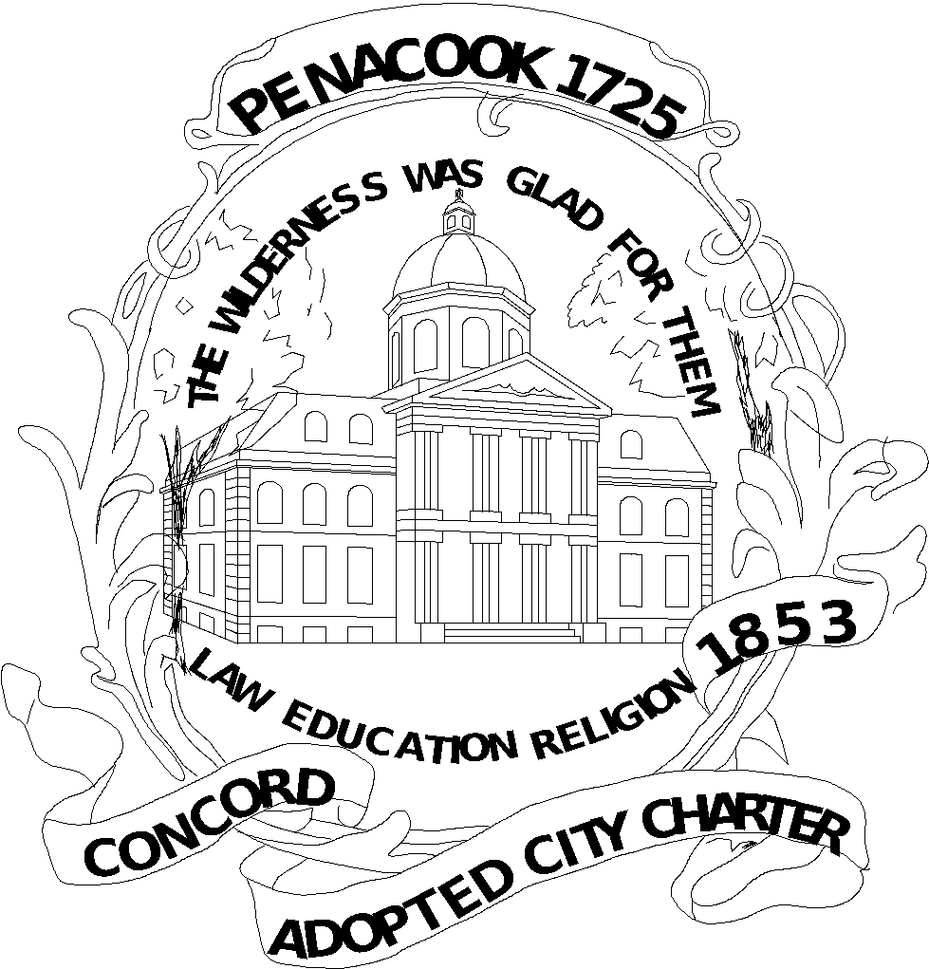
CITY OF CONCORD
MEETING MINUTES

CONCORD PUBLIC LIBRARY BOARD OF TRUSTEES

Monday, April 5, 2021
6:00 PM
Virtual Meeting using Zoom

- Attendance: Jeremy Clemans, Chris Casko, Ray Conner; Norm Kinsler; Lisa Sands; Ali Sekou; Todd Fabian
- J. Clemans opened the meeting at 6:06 p.m. by video conference using Zoom as the platform. The legal basis for a video is Governor Sununu’s emergency Order #12 pursuant to Executive Order 2020-04. The public could participate by video if they wished although there was no physical location for the public to attend. The board members could interact contemporaneously during the meeting.
- The first agenda item regarded acceptance of the minutes of the March 1, 2021 monthly meeting. By motion of C. Casko and seconded by J. Clemans, the board approved the minutes by unanimous vote.
- Next, T. Fabian gave the Library Director's Report and Monthly Update and COVID plans. The public will have to wear masks in the building through June. The library hopes to increase services soon. The CDC guidelines will be followed when patrons come back into the building. Curbside service will continue even after reopening happens. It may be moved to the side after the weather warms up again. An old trust that is closed and in the legal process is that a generous sum has been provided for $175,000 for visual and graphic art materials for adults and children. We will make a requisition to the council to use for specific gifts in accordance with the will. They have begun to discuss how to use the funds. The Dogman series is very popular and if we could get the author to come, it will be very well received, so J. Clemans discussed pursuing him doing a program at the library or through video conference. This money will allow us to think bigger than we normally would. During the closure, 2 display cases were purchased from grant funds. Art work will be rotated for display in these cases. They will soon be front and center for our marketing. As to budget, T. Fabian will have discussions with the council soon. The City of Concord, like other governmental units, has had less revenue during the pandemic. A very conservative budget has been drafted and will be presented. Some materials need to be used by the end of the budget year or they will not be available after the year’s close. More craft projects are being done to take home instead of people appearing in the building. L. Sands asked how audio downloadable books will work with the vendor changes, and T. Fabian briefed the board on changes from the Overdrive to the preferable Libby app. They have the same parent company so we pay only one user charge. As to vaccinations, the majority of the staff have received their first shots. The library will reopen next Monday for browsing and computer use and continue curbside pickups. Each patron will have a 30-minute time limit to browse to allow as many people to access the library as possible. Computer use will be 1 hour. As indicated last month, the heights branch will open before Penacook at some point down the road. The satellite locations have been closed for 1 year.
- New business- No one had any comments.
- Old business- as to next steps for the library expansion, B. Hermann shared information about some other projects and how they messaged library expansion. L. Sands encouraged other trustees to review the information if they had not done so.
- Library Foundation- A. Sekou updated the group concerning the fundraising being done by the group. They are working to get private donors to achieve their goals. The city will promote the campaign to raise funds for the boy and turtle sculpture downtown. They will contribute to this project. They discussed committee updates. A. Sekou indicated that gift cards will be delivered to the library staff in appreciation for their work from the foundation.
- T. Fabian began the next 5 to 10-year strategic plan discussions with staff. He will present the plan to the trustees and then the city. R. Connor suggested that alternatives with or without the new library project may be desirable. Moreover, he stated that some policies should be reviewed after the staff reviews them. The legal department also needs to review and then the policies are revised. T. Fabian asked about the mask policy so that it may be enforced. The trustees support adherence to all city ordinances, including that for masks. He will draft a sentence to add to Rules and Regulations concerning the mask ordinance for the trustees to review. As to other policies, he suggested that trustees review the Request for Reconsideration of Titles, Bulletin Board Policy, and Wireless Internet Access Policy. The Wifi stays on 24/7, so some patrons will sit outside and access the internet after hours. The trustees support continuing this same access. Not all libraries keep their Wifi on and turn it off after hours. This is a free speech issue and the policy should be updated to reflect this intent to keep it on at all times. The trustees will review these policies and they will be discussed at the May meeting. There is no update for Concord Reads. Since it is unknown when we can have a group presentation, we have not finalized a date for the event. Since it is a well-known author with a large cost, we don’t want to finalize the event until we know that we can have a productive turnout.
- Public Comments- None. No one appeared at the meeting from the public.
- Next Meeting: May 3, 2021
- Adjournment- 6:45 p.m. N. Kinsler moved to adjourn, seconded by A. Sekou and adopted by unanimous vote.
Respectfully submitted by:
Chris Casko, Trustee

All City of Concord public meetings are accessible for persons with disabilities. Any person who feels that they may be unable to participate in a City of Concord public meeting due to a disability should, to the extent possible, call (603) 225-8570 at least 48 hours prior to the meeting so that a reasonable accommodation can be arranged.

