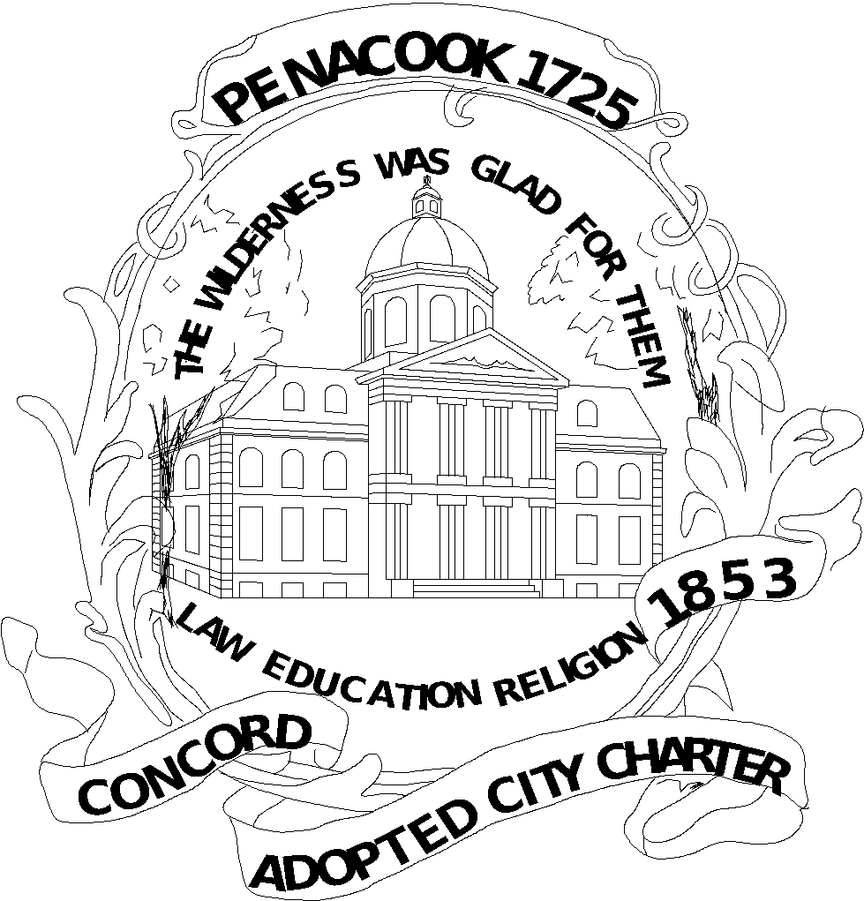
CITY OF CONCORD
MEETING MINUTES

CONCORD PUBLIC LIBRARY BOARD OF TRUSTEES

Monday, February 1, 2021
6:00 PM
Virtual Meeting using Zoom

- Attendance: Jeremy Clemans, Chris Casko, Becky Hermann, Ray Conner; Norm Kinsler; Lisa Sands; Charles O’Leary; Ali Sekou
- B. Hermann opened the meeting at 6:01 p.m. by video conference using Zoom as the platform. The legal basis for a video meeting are the emergency orders of Governor Sununu issued due to the COVID 19 State of Emergency. The public could participate by video if they wished although there was no physical location for the public to attend. The board members could interact contemporaneously during the meeting.
- The first agenda item regarded acceptance of the minutes of the January 4, 2021 monthly meeting. By motion of J. Clemans and seconded by N. Kinsler, the board approved the minutes by unanimous vote.
- Next, B. Hermann gave the Library Director's Report and Monthly Update and COVID plans. The library has a program on 2/18, African American Soldiers and Sailors During the American Revolution on and 2/25, Black Men in White Coats, a film about African American doctors, to celebrate Black History Month. T. Fabian will be on the City of Concord Diversity Committee. Curbside service only will continue due to COVID 19 restrictions. The new Youth Services Director, Becky Kasten has started. In the newsletter, her biographical information was shared. She is from Illinois. Some good news was reported that a trust closed and a $175,000 payment was received for visual arts and publications and graphic arts for adults and children. This is a continuing trust that has been funding these items for many years. It has been a significant contribution according to L. Sands.
- Old Business- Brainstorming on the next steps for the library expansion project. Last month, challenges were discussed. The City Manager shared useful information at a recent meeting last fall. The trustees shared some additional ideas for next steps. We need to think larger in order to get the general public interested in the project. The library should be a place of diversity and inclusion. We should put together a FAQ sheet and address questions that go beyond what has already been done. We should brainstorm common questions that will be asked about the project and provide answers, starting with the board coming up with a message as to why we need a new library. This will help us to answer questions from residents. It is a difficult time to discuss a new space when, because of COVID, we are closed. N. Kinsler pointed out that it is important to note that many of the library materials are in the basement and not accessible. A new space will allow for these to be displayed. L. Sands stated that we have a strong collection and need more space for people to work with items in the collection. For example, the Concord Room is a significant resource that the public may not even be aware of. We need to inform the public of what we have, in order to get them excited about our resources. The board could work on marketing items that are library resources to inform the public about what we offer. L. Sands stated that it will be beneficial to quantify the value of library resources as a way to inform the public about what they get in terms of the value that the library gives to individual library users. B. Herrmann will share a version of the library value calculator used by many libraries to display how much your library use is in actual dollars. The board will also compile some information in order to market the project to the public. It will contain information and a schematic of the new library and include questions about the cost and funding. B. Herrmann will send examples of what other libraries have used for marketing library expansion projects. N. Kinsler stated that a larger concept project that marries the community center, the city auditorium and an expanded library may be the big seller.
- J. Clemans suggested that a new middle school could be combined with a new library since the middle school will need to be updated. He also posed important questions that we need to answer: Why is a new library necessary? Why do some groups feel that a new library is not necessary? Both of these questions will need to be answered. Knowing what other groups are thinking will be important.
- B. Hermann expressed that after a lot of work towards a new library and where it should be located was done, the city administration concluded that the best choice was to leave the library at the current location although there are issues with the site like lack of parking. L. Sands reminded the board that the purchase price of new land was an issue that prevented the project from moving forward at another location. The old state employment security building was considered and determined not to be a suitable library location.
- C. O’Leary stated that he thought that the public desires a central downtown location in order to ensure that it is accessible. In addition, he stated that there are many different uses for the library and the current location has very limited accessible space.
- A. Sekou stated that he is supportive of a community center library concept which may result in greater support from the public so that all groups of people will be able to get use out of it. If the entire community is able to use the space, a broader plan may be more likely to be supported.
- R. Connor asked about previous charettes about what people wanted in a new library and where tit should be located. They occurred in 2007, a long time ago, and perhaps a new process should be considered. J. Clemans stated that another attractive location may be doable if people are able to get to it by bus. He wants to be sure that people in parts of the city farther from the library do not feel disenfranchised if the library stays downtown and that people close to the existing library don’t feel disenfranchised if the site is moved further away.
- L. Sands stated that the new plan is very flexible and can be tailored to what people want. She is excited about this interesting plan about what a library can look like. She felt energized by the plan. B. Hermann said that we are in an exploratory process which can change based on public input, which could include a new location. A. Sekou pointed out that building relationships with donors to the foundation is also critical to extend our outreach.
- New Business- As part of the Foundation update, B. Hermann shared meeting minutes from that group. They are considering new members who will make the Foundation membership more diverse. They discussed the boy and turtle sculpture on Main Street because the city has been renting it and it will need to be purchased for $15000 and then donated to the city in order to stay. They discussed if the Foundation can purchase the sculpture. They will think about it, but wondered why the city can’t fundraise in order to purchase the sculpture. Ultimately, T. Fabian indicated that the city will establish a fund to take donations to purchase this piece. The Foundation made their annual appeal which exceeded their expectation of approximately $16000. They raised approximately $17000 as part of the annual campaign. A key member, Patti Baum, resigned from the foundation.
- The library newsletter will include trustee profiles which will be compiled based on responses to a set of questions. L. Sands is the first person profiled in the newsletter. All trustees will get to do this.
- Next, the board conducted a team building exercise by describing a favorite (or not so favorite) food or recipe from their families. Those included muffins (light as a feather and able to be consumed in large quantities!), yiba, or rolled grape leaves, gelatinous white fish from Norway, a Jewish/Hungarian spicy pasta dish, quiche with graham cracker crust, fresh okra cut in small pieces with rice or yam, and chicken cacciatore with lima beans.
- Public Comments- None. No one appeared at the meeting from the public.
- Next Meeting: March 1, 2020
- Adjournment- 7:10. N. Kinsler moved to adjourn, seconded by A. Sekou and adopted by unanimous vote.

All City of Concord public meetings are accessible for persons with disabilities. Any person who feels that they may be unable to participate in a City of Concord public meeting due to a disability should, to the extent possible, call (603) 225-8570 at least 48 hours prior to the meeting so that a reasonable accommodation can be arranged.

